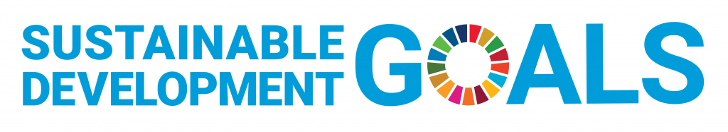
Level 13, 49 Boulcott St,
PO Box 24494,
Wellington 6011,
New Zealand
Job Description
UNANZ Social Media Officer

Overview
This Job description describes the Duties of the Social Media Office of UNANZ. In simple terms, this role is to work alongside other National Executive members to manage, create and post content for social media channels, namely, Twitter, Facebook and Instagram.

Context
The Social Media Officer for UNA NZ, a non-profit organization, plays a critical role in fostering communication, awareness of and engagement with our work. This allows us to further our purpose by promotion education about the UN and engagement with our events and projects. Outward facing communication on mainstream channels has not been central to UNA NZ’s work program previously, many of our members still communicate via email. The person taking on this role will have to support in the completion of our communications plan, and be confident in learning our brand voice quickly, developing the role and duties as they see fit.

Specific Duties
You will need to both use current and create new systems for managing social media content such as hootsuite, trello and similar. Based on our communications plan, our events, our projects, UN news and themes create, schedule and post social media content on Facebook, Twitter and Instagram.
Live tweeting during an event, posting on behalf of branches, interacting with commenters, resharing posts we are tagged in.
You will have ongoing communication channels with the National Administrator who manages the website, National Office, the Newsletter and formal communications to members. You will also have a close relationship with other communications officers who work across LinkedIn, press releases and blog posts as well as events officers who organise, run and promote our events.
The National Executive is a tight knit team of volunteers who meet every month and communicate often while working together, you need to be able to fit within this team as well as working confidently independently.
We are seeking someone who can understand our purpose, key stakeholders and work-streams quickly and create appropriate content. This includes sharing formal academic content, events, infographics and images, videos and interviews and more. The ability to use CANVAS, In design, or similar as well as connected apps like eventbrite will assist you in this role.

