UN@75 Celebration, 29 October 2020
Overview
The United Nations Association of New Zealand (UNA NZ) Te Roopu Whakakotahi Whenua o Aotearoa is holding a reception to mark United Nations Day 2020 on Thursday 29 October, 5.30pm-7.30pm, Grand Hall, Parliament Buildings and the official book launch of A Seat at the Table: New Zealand and the United Nations Security Council 2015–2016, edited by Graham Hassall and Negar Partow, Thursday 29 October, 4.00pm, Legislative Council Chamber, Parliament Buildings. Hosted by the Rt Hon Trevor Mallard.
The purpose of these events is to celebrate the 75th anniversary of the United Nations, reflect on the future of multilateralism, and hear from a fantastic range of speakers giving diverse perspectives from the diplomatic, youth, academic, and UN communities.
Featuring artworks and music from Whenua Ūkaipō Connectedness 2020 United Nations 75th anniversary art exhibition, bringing forward authentic Māori, indigenous and many cultures artistic visions to the United Nations Sustainable Development Goals.
With support from Massey University Press and the Ministry of Foreign Affairs and Trade.
About the United Nations Association of New Zealand
UNA NZ is a national community organisation, and a registered charity. It is made up of a number of regional branches, an independent youth association (UN Youth New Zealand) and affiliates across New Zealand. UNA NZ was founded shortly after the United Nations itself in 1945, and is formally associated with the UN Department of Public Information. We are a member of The World Federation of United Nations Associations (WFUNA), which provides links with United Nations Associations in other countries throughout the world.
UNA NZ members come from all areas and walks of life. What brings them together is a shared interest in the work of the United Nations and in trying to make the world a better place. UNA NZ is also affiliated with a number of organisations who are looking for synergies and collaboration. It is supported by the We the People’s Foundation to grow a capital base for the organisation.
Recent activities have covered a diverse range of topics: the UN Global Contract on Migration, Linear to Circular Economy, Sustainable Development Goals as a tool for the post COVID-19 economy, Family Violence in a time of Pandemic, International Day of UN Peacekeepers: Women in Peacekeeping, Youth activism around the world in achieving the 2030 Agenda, and an ASEAN-focused diplomatic event. We also delivered a full day National Conference virtually, looking back over the United Nations at 75, and a week-long campaign to mark the 5th birthday of the SDGs.
Our branches continue to foster scholarship and creative engagement in the work of the United Nations, and our network of enthusiastic members and interns is growing both in New Zealand and abroad.
The future we want, the United Nations we need: reaffirming our collective commitment to multilateralism.
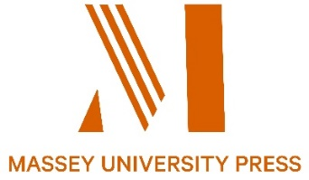
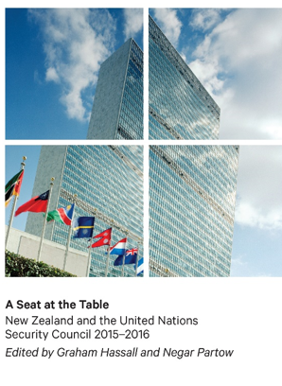
Key biographies

Book launch

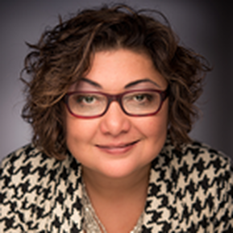 | Dr Negar Partow (panel convenor) is a Human Security specialist and senior lecturer in the Centre for Defence and Security Studies at Massey University’s Wellington campus. She has taught and written extensively on the dynamics of politics and religion, international security, ethics, human security, the Middle East religions and security environment, the United Nations’ peacekeeping operations and human rights. Negar holds a PhD from Victoria University and two Master’s degree from Iran and New Zealand. She has supervised many research topics on security and defence and has been a consultant for various government departments in NZ. In addition to teaching, Negar is a regular media commentator on various issues and has worked with civil society groups and NGOs on human security issues.
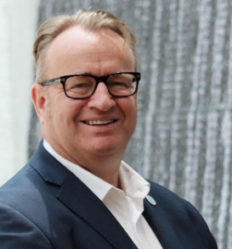 | Simon J Draper, Executive Director is an experienced diplomat with an extensive international background in negotiation and relationship management.  He joined the Foundation in September 2015, coming from the Ministry of Foreign Affairs and Trade (MFAT) where he has worked in various roles since 1991. Most recently he held the role of director of the United Nations, Human Rights and Commonwealth Division. In this role, he managed New Zealand’s engagement and policy with the United Nations in New York, the Human Rights Council in Geneva, and the Commonwealth in London. A key part of the role was to drive New Zealand's successful campaign for a United Nations Security Council seat.  Simon has held several other leadership positions within MFAT, including New Zealand’s Consul-General to French Pacific Territories (2008-2011), director of the chief executive’s office (2005-2008) and foreign policy adviser to Rt Hon Simon Upton. Before joining MFAT, he worked in the banking and consultancy sectors. He speaks working level Korean, French and Italian.
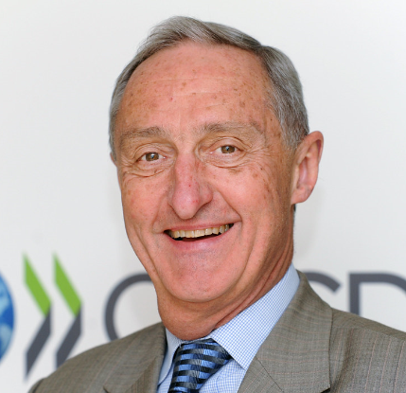 | Dr James Kember is the NZIIA Chair of Research and Publications Committee, former New Zealand Ambassador  Dr Kember has served as New Zealand’s Ambassador to France, and previously was Ambassador to the African Union and Ethiopia. He has also served as Head of Mission in Viet Nam, Hong Kong and the Cook Islands, and carried out assignments to the United Nations in New York and to New Caledonia.
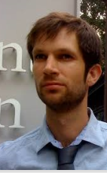 | Nicholas Walbridge was the Private Secretary (Foreign Affairs) in the Office of the Minister of Foreign Affairs and a former lead adviser United Nations, Human Rights and Commonwealth Division, Ministry of Foreign Affairs and Trade (2017), political coordinator New Zealand Permanent Mission to the United Nations, New York, United States (2016), Africa Coordinator / Deputy Political Coordinator (2013-2016), and research analyst for the Security Council Report (2011-2013)  He holds a Master’s degree in Political Science (International Relations) from Leiden University, and an LLB/BA from Victoria University of Wellington.
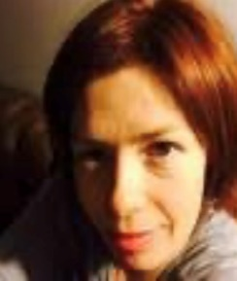 | Nicola Hill is the Assessments Manager, National Assessments Bureau, Department of Prime Minister and Cabinet. She is a former diplomat with twenty five years foreign and security policy experience including as New Zealand’s Political Coordinator to the United Nations Security Council in 2014-15 and Special Adviser to New Zealand’s UNSG campaign for Helen Clark in 2016. She has served twice in New York, including being elected Vice-President of the UN’s human rights committee in 2009 in her personal capacity and as assistant to the Chair concluding the Convention on the Rights of Persons with Disabilities in 2006.
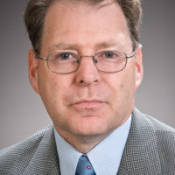 | Dr Graham Hassall is a Research Associate and former Associate Professor in the School of Government at the Victoria University of Wellington. His research focuses in two areas: the public sector in the Pacific Islands, and global public Policy and institutions. He has lived in and taught at Universities in Australia, Switzerland, Papua New Guinea, Fiji, and now New Zealand. He is a life-member of the United Nations Association of New Zealand, having served as national President 2012-2016, and he as the Chair of the New Zealand Centre for Global Studies.  (Co-editor, joining via Zoom from Queensland).

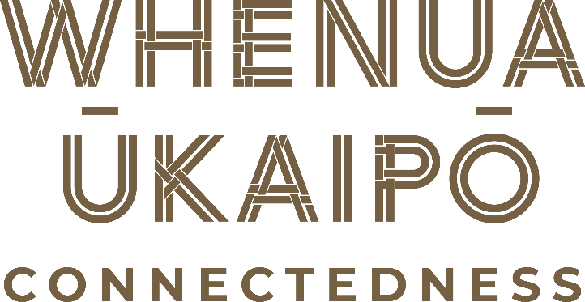
UN Day Reception

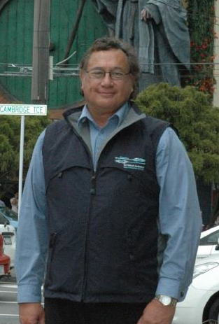 | Garry Nicholas, General Manager, Te Atiawa, Ngati Ruanui, Taranaki, Ngaiterangi and Ngati Ranginui. Arts administrator and advocate, Garry has over 20 years’ experience in the Contemporary Māori arts area. His principal area of expertise is in the visual arts however within his current role as General Manager of Toi Māori Aotearoa | Māori Arts New Zealand he has a wide appreciation of Maori arts. It is in the area of arts structures and networks he has specialised. In 1987 he was appointed to Māori and South Pacific Arts Council (MASPAC) as Executive Officer.  In 1995 as a guest of the Chicago Department of Cultural Affairs he studied institutions and community arts organisations of African American, Mexican, Latino and Native American arts. In 1996 he was seconded to Te Papa as Iwi Concept Developer for the exhibition based on Te Whanganui a Tara. In 1998 he briefly returned to his role as Māori Arts Adviser to Creative New Zealand before taking up his current position as General Manager at Toi Māori Aotearoa.  In October 2005, Garry worked very closely with Tourism New Zealand to present the hugely successful NZ promotion ‘Māori Art Meets America’ to San Francisco.  In 2007 Garry and the Toi Maori team collaborated with Pataka to create the first Maori MARKet, held at the TSB Arena in Wellington. In October 2009 Toi Maori and Pataka teamed up again to create Maori ART MARKet at Te Rauparaha Arena in Porirua, this saw over 200 artists’ exhibit their works. In 2010 he successfully led negotiations for the building & loan of the ceremonial waka Te Hono ki Aotearoa to the Volkenkunde Museum of Leiden, Netherlands.
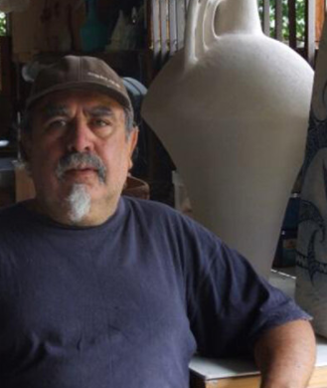 | Baye Pewhairangi Riddell, Ngāti Porou, began working with clay in 1974 as a studio potter in Christchurch, NZ. Since then he has worked back in his home area of Te Tai Rawhiti – the East Coast – primarily in Tokomaru Bay. He co founded Kaihanga Uku – Māori Ceramists Group in 1987 and this group has been responsible for a huge development in Māori ceramics and in fostering links with other indigenous clay artists. Baye Riddell has exhibited and run courses and workshops in marae, tertiary institutions and galleries throughout NZ and internationally.  “Baye Riddell is an artist whose work emerges from the soul of the land and the sea. His work sings of the land, like the earth mother gently beating out her heart rhythms in order to gather in her children. At times a profoundly religious man, he has developed symbols and new shapes to his work that rationalise his oneness with universal concepts. More recently his work has taken figurative form with new symbols while at the same time not losing the organic and earthy feel which typifies his best work.“- Darcy Nicholas.
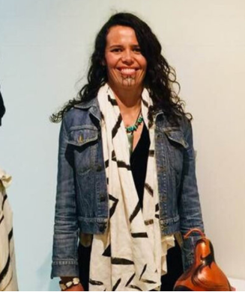 | Piri Cowie, Kāi Tahu, Ngāpuhi, Ngāti Kahu primarily works as a sculptor, her works include artistic expressions in paint, bronze, rākai, fabric design and more recently glass. Her artworks have been exhibited nationally and internationally. Piri has completed several public art commissions, for Te Rūnanga ō Ngāi Tahu, honouring tuna (eels), her steel sculpture “Kirihao - Resilience” is situated at the Pita Te Hori Centre, Ōtautahi, Christchurch. She also created seven bronze eels for “Te Hononga,” the Christchurch Civic building. From 2014 to 2015 Piri completed integrated art designs at Tākaro ā Poi, Margaret Mahy Family Park, Christchurch. In 2014, thanks to the generous support from Creative New Zealand Piri was able to participate in the Artists in Residence - Vallauris, France. Piri also returned to Paris, France with support from Creative New Zealand in September 2015 to be mentored by Marian Fountain in the creation of bronze medals. Piri has developed her art practice through attending International Indigenous Visual Artist Gatherings in New Zealand and the United States. In 2019, Piri was invited to engage in the International Hot Shop Visiting Artist Residency at the Museum of Glass, Tacoma, Washington. Her glass artwork, Nga Tuna Heke – Migrating Eels, is now part of the Permanent Collection of the Museum of Glass, Tacoma, Washington, United States.
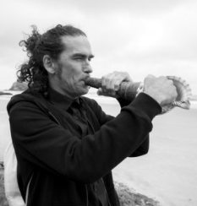 | Rob Thorne, Ngāti Tumutumu, M.A. is a Māori composer, performer, improviser, collaborator, anthropologist and specialist; an explorer in the evolving journey of Taonga Puoro (traditional Māori instruments).  Using modern looping technology and traditional Māori flutes and horns made from stone, bone, shell and wood, Rob creates a transcendent aural experience that touches the soul with timeless beauty. Every performance of "Whāia te Māramatanga" is a stunning and very personal exploration of the spiritual and healing qualities of an ancient practise.  Rob’s combined musical and academic experience and skills are multitudinal. A musician with over 25 years performance experience in bands and solo, predominantly within alternative rock, free noise, experimental, and improvisational sound art, his work since 2001 with traditional Māori musical instruments (taonga puoro) has seen him complete an MA in Social Anthropology, and since 2008, incorporate this diverse experience to create long, beautifully transcendent, ambient compositions using loops, intelligently blending the modern with the ancient: a format that is now being picked up and utilised by many taonga puoro players.

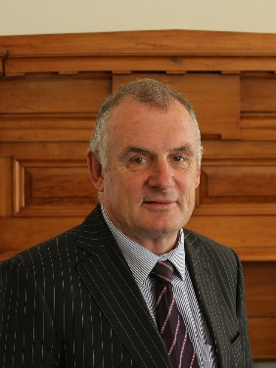 | Rt Hon Trevor Mallard was the Speaker of the New Zealand House of Representatives for the 52nd Parliament.  In his role as Speaker, Trevor chairs meetings of the house and maintains order for house business, ensuring balance and making decisions on matters of procedure. Trevor also represents the House internationally by meeting with leaders and parliamentarians from around the world.  Prior to his election as speaker, Trevor served as a Member of Parliament for 30 years, since 1984. He served as a whip in the fourth Labour government and then as a Minister, including Education and State Services 1999-2005, Sport 1999-2007, State Owned Enterprises 2005-2008, Associate Finance 1999-2008. Before his election to Parliament, Trevor worked as an accountant, teacher and rural adult education organiser. He has been the licensee of an early childhood centre, the President of the Student Teachers Association of New Zealand and a trade union official in the King Country.
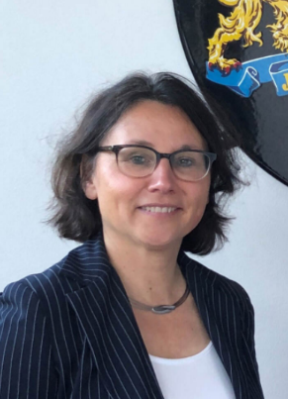 | Her Excellency Ms Mira Woldberg is the Ambassador of the Kingdom of the Netherlands to New Zealand, Fiji, Samoa, Tonga, Kiribati and Tuvalu. The Ambassador has been working at the Netherlands Ministry of Foreign Affairs since 1998. She has held several offices at the Ministry in The Hague, as well as postings abroad in Jakarta, Indonesia (2001 – 2005) and New York, USA (2005 -2010), and has been posted in New Zealand since 2018. She holds a Master of Law in International Law
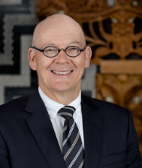 | Chris Seed took up the role of Chief Executive and Secretary in February 2019. Prior to taking up this position, Chris spent five years (2013-2018) as New Zealand’s High Commissioner to Australia.  Chris first joined MFAT in 1985. He was Deputy Secretary for the Australia, Pacific, Europe, Middle East and Africa Group from 2008-2013. His earlier career included assignments in Tehran, Canberra, London and Papua New Guinea, where he was High Commissioner. Chris also spent some time in the Ministry of Defence as Deputy Secretary, Policy and Planning from 2004-2008.  In addition to a number of roles in Wellington, Chris has served with the International Peace Monitoring Team in the Solomon Islands, the New Zealand delegation to the UN General Assembly and was seconded to the Australian Department of Foreign Affairs and Trade.  Chris holds a Master’s Degree in History and a BA with First Class Honours from Massey University.
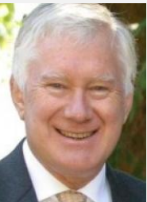 | Colin Keating is a former Permanent Representative of New Zealand to the United Nations. He served from 1993 - 1996 and on the Security Council from 1993-1994, present for both the Rwandan Genocide and the mission to Somalia.  He is a Senior Research Fellow at Columbia University and was the Executive Director of Security Council Report, an institution producing reports on the UN Security Council and working to increase its transparency and effectiveness.
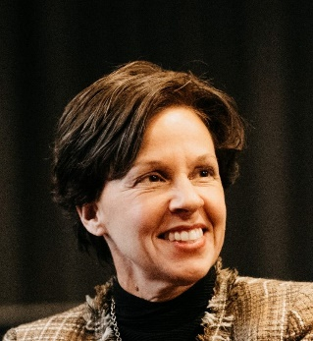 | Louise Aubin is the United Nations High Commissioner for Refugees (UNHCR) Regional Representative to Australia, New Zealand and the Pacific Islands. Since joining UNHCR, she has served in a number of refugee and internal displacement operations including Central African Republic, Rwanda, Guinea, Ethiopia, Kenya, Bangladesh, in addition to legal and advocacy work in Canada and in France.  Before coming to Australia, she was Deputy Director in the Division of International Protection at UNHCR’s Headquarters in Geneva. Ms Aubin is a Canadian lawyer.
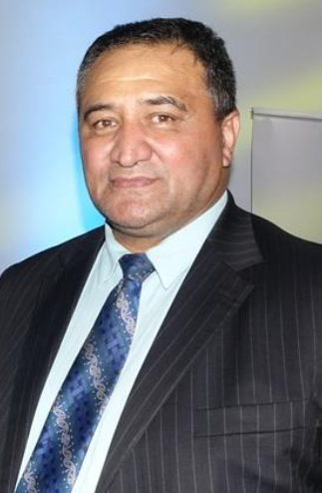 | Kura Moeahu is the New Zealand Parliament’s Tumu Whakarae, Principal Cultural Adviser.Kura has strong mana whenua ties here in Te Whanganui a Tara, Wellington. He has whakapapa connections to the eight tribes of Taranaki and Ngāti Mutunga. He is a tribal leader for his people, who is passionately involved with his iwi governance (Te Ātiawa) and has been actively involved in iwi governance as both a chair and board member, including as Chair of Te Rūnanganuio Te Ātiawa, the Waiwhetu Marae Trust, the Harbour Island Kaitiaki Board, and Waiwhetu Pa Reserve Trust.  As a member of the Weltec Māori Advisory Board, he was instrumental in establishing Te Auaha, the NZ Institute of Creativity and is widely recognised for his knowledge of te ao Māori, tikanga Māori and Māori arts. In 2020, he joined the Arts Council of New Zealand Toi Aotearoa (the board of Creative New Zealand).
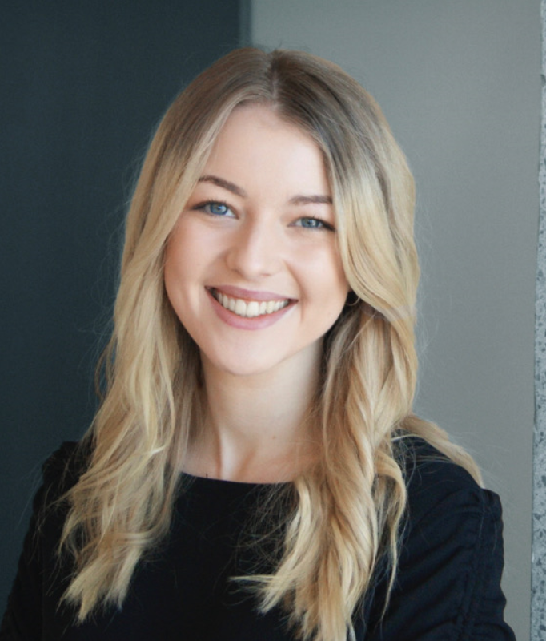 | Maisy Bentley is in her fourth year of an LLB (Hons) and BA (International Development and Māori studies) Maisy works as the Executive Officer for the United Nations Association of New Zealand. She is also an intern at the YWCA, and works across various community and academic organisations. Maisy has significant achievements under her belt both academically and in practice, including being named “Outstanding Youth Champion" by Minister for Youth, Thomson Reuters Top Student in Contract Law and Most Inspirational Young Person of the Year.  She is interested in sustainable development, the UN, human rights (with a focus on women’s rights) and emerging legal issues resulting from technology developments. With a focus on using her legal and academic skills for social good Maisy has work on international policy and Waitangi Tribunal claims at the Ministry for Women, participated in global policy making at the UN in New York and contributed to several academic reports and publications.
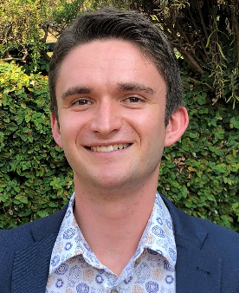 | Mark Howard is the National President of UN Youth New Zealand, the independent youth branch of UNA NZ. Each year, UN Youth engages with thousands of young people from Invercargill to Kaitaia, providing spaces to learn about the values of the United Nations, critically discuss global issues and bring youth voice to the community, national and international stage. As National President, Mark is responsible for overseeing all of UN Youth's initiatives. Beyond UN Youth, Mark is in his fifth year of studying law and education at the University of Auckland.
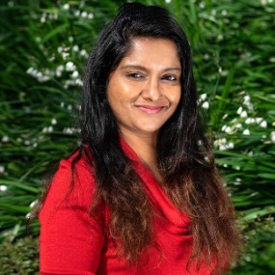 | Gaya Paranisamy is the Vice-President of the United Nations Association of New Zealand. She is a Quantity Surveyor from Malaysia and has worked in many different construction project across Malaysia. She migrated from Malaysia 5 years ago to work on the Earthquake Rebuilding in Christchurch. Currently, she is working as a Cost Manager in an Engineering Consultant Company in Wellington. She is also a committee member for NAWIC (National Association of Women in Construction). Last year, Gaya won a “Highly Commended Award” for Rising Star category, NAWIC Award. Gaya is very passionate about Sustainability in Construction and equality.

