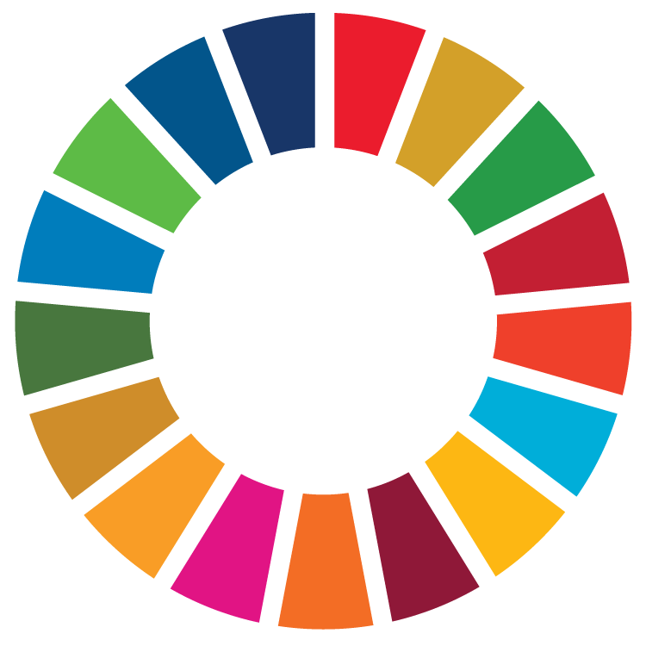

United Nations Association of New Zealand Annual Conference 2021

Building Back Better

Programme

Day 1 – Friday 13th August
Grand Hall, New Zealand Parliament, 1 Museum Street, Pipitea

Time | Session | Information
5:30 | Registration | Refreshments will be served prior to the formalities
6:00 | Welcome address | Welcome address on behalf of UNA NZ acknowledging the 75th anniversary of UNA NZ
6:10 | Keynote address | A keynote address from our Host MP Vanushi Walters.  MP Vanushi Walters was elected as the member of Parliament for Upper Harbour in 2020 and sits as Deputy Chair of the Justice Select Committee and is a member of the Regulations Review Committee. With private, public, and community sector experience, Vanushi has held Governance roles with Amnesty International, Action for Children and Youth Aotearoa.
6:35 | Refreshments and networking | Refreshments will be served following the formalities while attendees network
7:30 | Conclusion | The event will conclude by 7:30

Day 2 – Saturday 14th August
Grand Hall & Legislative Council, New Zealand Parliament, 1 Museum Street, Pipitea

Time | Session | Information
9:15 | Registration | Please arrive from 9:15 to register before 9:30
9:30 | Opening and welcome | The event will be open with a Karakia and a welcome address by UNA NZ president Gaya Paranisamy
9:40 | Dame Laurie Salas Memorial Address by Dell Higgie | Dell Higgie will deliver the Dame Laurie Salas Memorial Address.  Although recently retired from an impressive diplomatic career – involving being NZ’s Ambassador for Counter-Terrorism, and a Permanent Representative to the UN and Conference on Disarmament – she continues as an Ambassador-at-Large for MFAT, and as Chair of the Geneva-based Trust Fund for the Arms Trade Treaty.
10:10 | Address from Associate Professor Mere Skerrett | Associate Professor Mere Skerrett will discuss the theme from an education perspective.  Associate Professor Mere Skerrett has an extensive background in teaching and researching in early childhood and primary education sectors, with a focus on Te Reo/English bilingualism. She is an International Research Fellow with the Velma E. Schmidt International Critical Childhood Policy Studies Collaborative.
10:40 | Morning Tea
11:00 | Keynote Address from Hon Nanaia Mahuta | Hon Nanaia Mahuta will present the keynote speech. The Minister will discuss the value of international commitments in working towards building back better, and the role Aotearoa New Zealand could play.  Hon Nanaia Mahuta is the current Minister of Foreign Affairs – the first indigenous woman to hold this portfolio – the Minister of Local Government, and Associate Minister for Māori Development.
11:30 | Address form H.E. Ambassador Nina Obermaier | Ambassador Nina Obermaier will discuss the theme from a diplomatic perspective, specifically between Aotearoa New Zealand and the EU.  Ambassador Nina Obermaier is the EU Ambassador to Aotearoa New Zealand and is part of the European External Action Service. Notable positions include working as the Advisor to the Deputy Chief Negotiator as part of the negotiation process for the UK withdrawal from the EU.
12:00 | Bead and Proceed workshop | Bridget Williams will deliver a high-energy presentation getting everyone up to speed on the SDGs and why they matter. Attendees will each have the chance to paint a bead that represents the SDG they want to personally commit to. While painting attendees discuss why they have chosen their SDG and actions they will take towards progressing it. A stunning work of art is created from the beads that symbolises the joint commitment of the attendees.
1:00 | Lunch
2:00 | Panel | Panel moderator: Peter Nichols  Panel speakers:  - Megan McCoy, MOH General Manager Global Health and Director-General Advisory, and WHO former Technical Officer  - Chris Dunlop, Beca Regional Manager  - Dr Karanina Sumeo, Equal Employment Opportunities Commissioner at NZ Human Rights Commission  - Professor Siah Hwee Ang, Professor of International Business and Strategy, Chair in Business in Asia at Victoria University of Wellington, and Director of the Southeast Asia Centre of Asia-Pacific Excellence
3:00 | Closing remarks | Closing remarks will be offered on behalf of UNA NZ.
3:10 | Afternoon tea | Guests are invited to join us for afternoon tea following the closing remarks.
4:00 | Conclusion | The event will conclude at 4:00

UNA NZ 2021 National Conference - Speakers

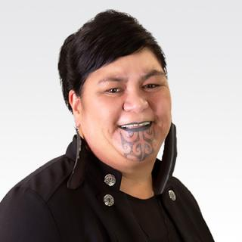  Hon Nanaia Mahuta | Hon Nanaia Mahuta is currently the Minister of Foreign Affairs. She is the first woman to hold this portfolio. She is also the Minister of Local Government, and Associate Minister for Māori Development. During her years in Parliament, Nanaia supported policies and initiatives around building the capacity of communities, social services organisations, investment in education, employment and training opportunities for young people, and the continuation of the Treaty settlement process.  Hon Nanaia Mahuta is a tribal member of Waikato-Tainui, Ngāti Maniapoto and Ngāti Manu.
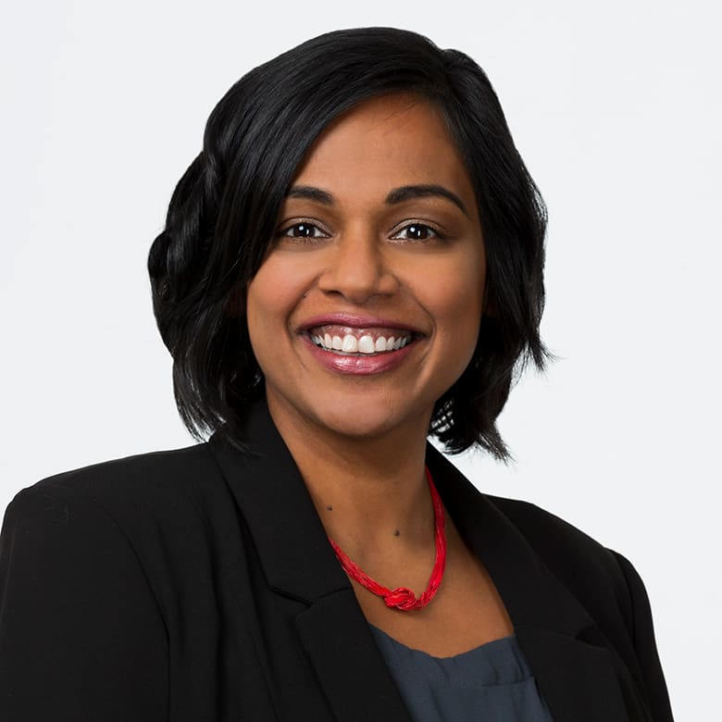  MP Vanushi Walters | MP Vanushi Walters - a Sri Lankan New Zealander whose family moved to New Zealand in 1987 - was elected as the member of Parliament for Upper Harbour in 2020. Her background is in law, and she has experience in the public, private and community sectors; including governance roles in Amnesty International, Youth Aotearoa and Action for Children; and senior management roles as General Manager of YouthLaw Aotearoa, and manager of the Human Rights Commissions’ advisory and research team. Walters is currently sitting as Deputy Chair of the Justice Select Committee, and is a member of the Regulations Review Committee.
Ex-Ambassador Dell Higgie  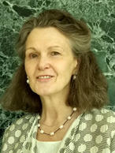 | Dell Higgie was a career diplomat with the New Zealand Ministry of Foreign Affairs & Trade until her retirement earlier this year. Her Wellington-based appointments have included: New Zealand’s International Trade Law Adviser, and 6 years as New Zealand’s Ambassador for Counter-Terrorism and Director of MFAT’s International Security and Disarmament Division. Her overseas appointments have included serving as Ambassador to the EU, Belgium, Luxembourg and Denmark; and Permanent Representative to the UN and Conference on Disarmament (CD) in Geneva. For the last 12 years she has been New Zealand's Ambassador for Disarmament. She continues, post-retirement, as an Ambassador-at-Large for MFAT, and remains as Chair of the Geneva-based Trust Fund for the Arms Trade Treaty.
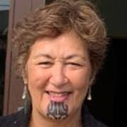  Associate Professor Mere Skerrett | Dr Mere Skerrett is an Associate Professor, and Partner Head of School in the School of Education at Victoria University of Wellington Te Herenga Waka. She has a background in teaching and researching in both early childhood and primary education sectors, with a focus on Kōhanga Reo and Māori/English bilingualism. She has previously been the recipient of a doctoral award and networking award from her Tainui people, and won the Te Pā Harakeke Award of commitment to Kāi Tahu whānau and leadership in Te Reo Māori. Dr Skerrett is also an International Research Fellow with the Velma E.Schmidt International Critical Childhood Policy Studies Collaborative under the leadership of Professor Gaile Cannella.
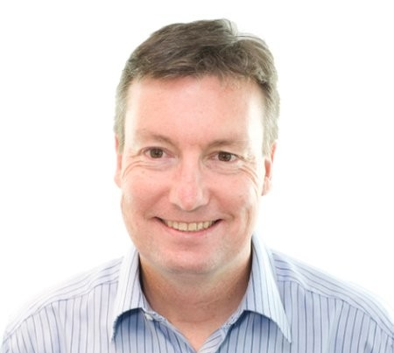  Chris Dunlop | Chris Dunlop is the Regional Manager for Beca in the Central Region of New Zealand. Beca is a leading Asia-Pacific professional services company with business headquarters in Auckland, New Zealand.  He has experience from his engineering consultancy work in New Zealand and the UK. There, he successfully led and delivered projects for clients in government, health, education, commercial office, retail, and defence.
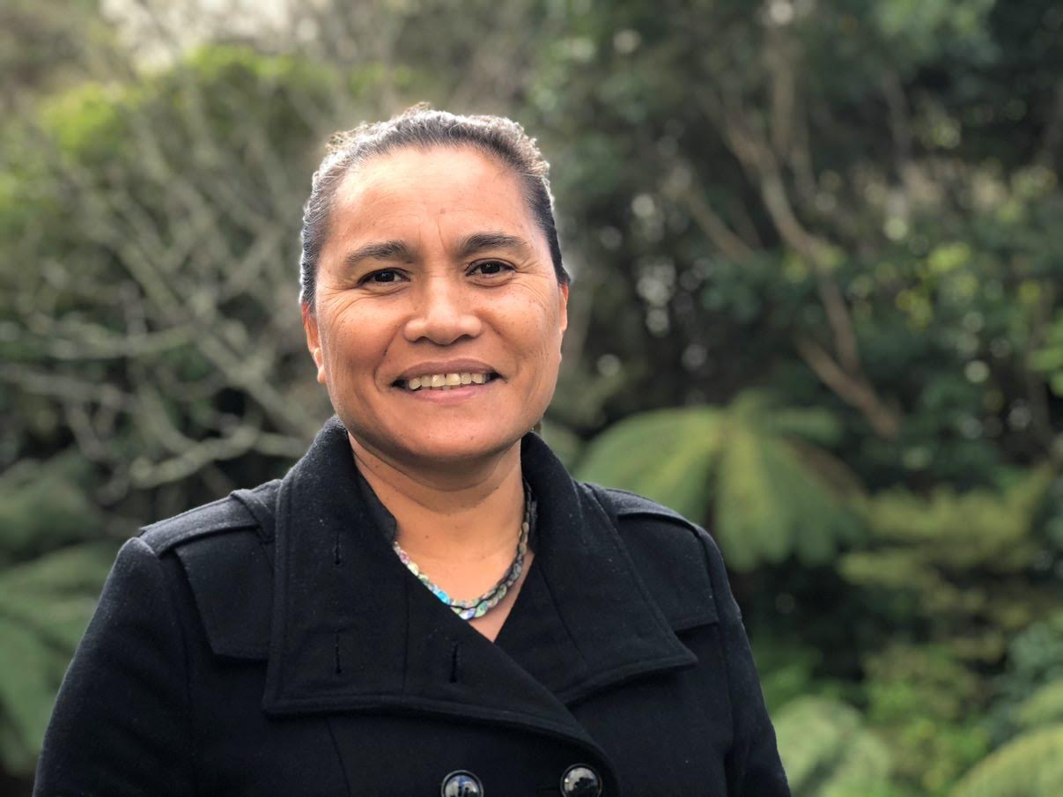  Dr Karanina Sumeo | Saunoamaali’i Karanina Sumeo is the Equal Employment Opportunities Commissioner at the New Zealand Human Rights Commission.  Saunoamaali'i has worked as a public advisor, consultant, and social worker, advocating for the rights and interests of children, youth, women, Rainbow, and Pacific communities. Saunoamaali'i holds qualifications in science, social work, and social policy including a PhD in public policy from AUT.
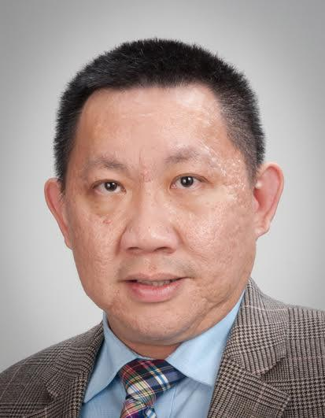  Professor Siah Hwee Ang | Siah Hwee Ang is Professor of International Business and Strategy and the Chair in Business in Asia at Victoria University of Wellington. He is also the Director of the NZ’s Southeast Asia Centre of Asia-Pacific Excellence. Siah’s research centres around the connection between international business and international trade. Before joining Victoria University of Wellington, Siah served as a Professor and Associate Dean at the University of Auckland Business School. As well as this he has work experience in City University in London and National University of Singapore, where he completed his PhD in Management.
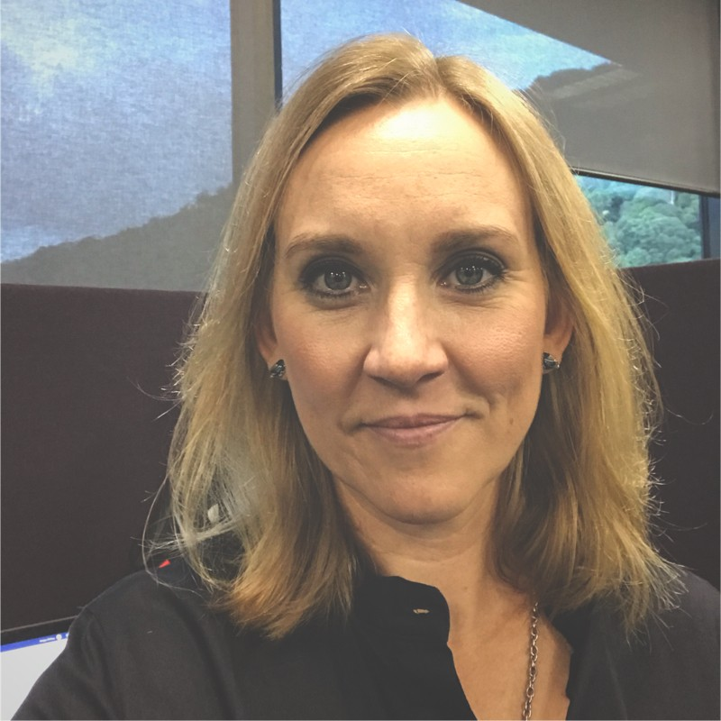  Megan McCoy | Megan McCoy is the General Manager of Global Health and the Director General Advisory in the Ministry of Health. In her previous roles she has worked as a Director in the Office for Disability Issues as well as Technical Officer in the World Health Organisation. In her current role Megan is responsible for leading and supporting the Ministry’s international engagement. This includes participation in governance at the World Health Organisation and working with partners in the Pacific region. Most recently she has led the roll-out of New Zealand support for COVID-19 vaccine roll-out in the Pacific.
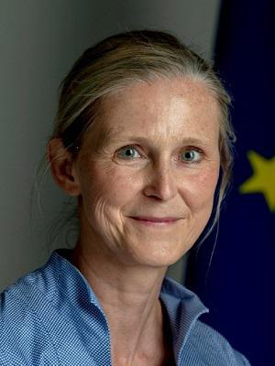  Ambassador Nina Obermaier | Ambassador Nina Obermaier is currently the European Union Ambassador to New Zealand. She is a part of the European External Action Service. Previously she has worked as the Advisor to the Deputy Chief Negotiator where she prepared and conducted negotiations for the UK withdrawal from the European Union. She has also worked as the Deputy Head of Division in the European External Action Service where she engaged in negotiations for an institutional framework agreement with Switzerland, the EEA and other small sized states.. Ambassador Nina Obermaier holds a Masters of European Studies from the College of Europe.
Bridget Williams | Bridget Williams is the CEO and founder of the social enterprise Bead & Proceed. Through workshops, Bridget works to teach and engage people with the 17 UN Sustainable Development Goals. As a former solicitor Bridget has developed an ability to show great leadership qualities, which she has presented through her various governance roles. Currently she is serving as Chair of the Fendalton/Waimairi/Harewood Community Board, and as a trustee of the Christchurch Arts Festival. She is also an active member of the Asia New Zealand Foundation Leadership Network and Curator of the World Economic Forum Global Shapers Christchurch Hub.

UNA NZ 2021 National Conference - Leaders and Moderators

Gaya Paranisamy  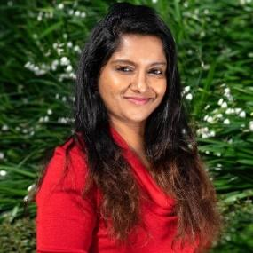 | Gaya Paranisamy is the President of the United Nations Association of New Zealand. She is a Quantity Surveyor from Malaysia and has worked in many different construction projects across Malaysia. She migrated from Malaysia 5 years ago to work on the Earthquake Rebuilding in Christchurch. Currently, she is working as a Cost Estimator at Transpower in Wellington. She is also a committee member for NAWIC (National Association of Women in Construction). Gaya is very passionate about Climate Change and equality.
Peter Nichols  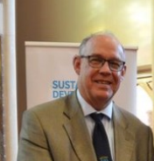 | Peter Nichols is the previous President of the United Nations Association of New Zealand. He has an extensive career in both the international and domestic spheres. His previous roles have been in, for example, Singapore/Malaysia for 5 years, and Indonesia/Philippines for 5 years where he worked in the New Zealand Embassy. Domestically, Peter has worked for the NZ Defence Force, 2 Governors General, the Department of Prime Minister and Cabinet in the Domestic and External Security Group and managed security at Parliament for 5 years. He has been heavily involved in a number of organisations, including in UNA NZ, the New Zealand Indonesia Association and Council, and as Chair of the Wellington Branch of the New Zealand Institute of International Affairs.  .

About the United Nations Association of New Zealand
The United Nations Association of New Zealand (UNA NZ) is a national community organisation, and a registered charity. It is made up of a number of regional branches, an independent youth association (UN Youth New Zealand) and affiliates across New Zealand.
UNA NZ was founded shortly after the United Nations itself in 1945, and is formally associated with the UN Department of Public Information. We are a member of The World Federation of United Nations Associations (WFUNA), which provides links with United Nations Associations in other countries throughout the world.
UNA NZ members come from all areas and walks of life. What brings them together is a shared interest in the work of the United Nations and in trying to make the world a better place.
UNA NZ is also affiliated with a number of organisations who are looking for synergies and collaboration. It is supported by the We the People’s Foundation to grow a capital base for the organisation.
If you would like more information about UNA NZ and membership, please contact the National Office on (04) 496 9638, or office@unanz.org.nz, or visit our website https://www.unanz.org.nz/participate/
You can also connect with us on Social Media and follow upcoming events and news!

